Bryce Grant, Marlee Scholten, Jackie Tierney, Clare Tyler

December 10, 2021

POSTURE CORRECTION DEVICE FOR POST-STROKE PATIENTS

Project notebook

Table of Contents

Team Members 2

Determining Course Project 2

Selected Need 7

Vision Statement 7

Mission Statement 8

Development Process 9

Prototyping Plan 9

Data Collection Plan 10

Task List 11

Design Structure Matrix 12

Gantt Chart 13

PERT Chart 14

Budget 15

Risk Plan 16

Product Specifications 17

Concept Generation 19

Concept Selection 30

References 32

# Team Members

**Bryce Grant:** Undergraduate in Biomedical Engineering/Math; expertise in both python and c++; focus in electrical engineering

Role: Coding

**Marlee Scholten:** Undergraduate in Biomedical Engineering; works in Engineering Innovation Center and therefore can work well with 3D printers, laser cutter, woodshop tools; focus in mechanical engineering Role: Biomechanics/biological prototyping

**Jackie Tierney**: Undergraduate in Mechanical Engineering; have worked with MATLAB to analyze neurological signals (brain and muscle activity)

Role: Signal processing

**Clare Tyler:** Obtaining PhD in Biomedical Engineering; experience with MATLAB and inertial measurement units (IMUs); working on biomechanics-related research

Role: Biomechanics, proposal writing

# Determining Course Project

**List of Opportunities**

* Stroke patients and brain tumor patients who have incorrect posture may require posture correcting devices.
* There is not a viable way to conceal and protect wound bags for patients, making patients uncomfortable and impeding therapy.
* Patients suffering from dysphagia do not have access to developed therapy processes at home.

**Factors for Filtering Opportunities**

* Feasibility
  + Product availability
  + Amount of time
* Social considerations
* Backgrounds of team members
  + Course/research knowledge

**Real-Win-Worth It Frameworks for Our Top 3 Opportunities**

*Posture Correcting Device*

1. Is there a real market and a real product?

|  |  |
| --- | --- |
| Is there a need? | Yes. During Jackie’s time in outpatient orthopedic PT, many of the complaints were due to incorrect posture, and in neuro PT, many post-stroke patients were fearful of their weakened side and had to have the therapist remind and reassure them to use that side. |
| Can the customer buy? | Yes* (if the project proceeds from the concept development phase and passes regulations and insurance). |
| Will the customer buy? | Yes, with approval from their therapist. The key to purchase for older patients will be the convenience of the device over dependence (many people are wary of complete trust in a technology to do something for them). |
| Is there a viable concept for the product already? | Yes! There is the UprightGo, which is a little adhesive device that people can wear around their neck or stick in between their shoulder blades with a skin-safe adhesive that uses a gyroscope and accelerometer to determine a person’s position in space and gently remind them with a small vibration to fix their posture. However, this is targeted towards office workers and primarily sedentary workers for back and neck pain. |
| Is the product acceptable within the social, legal, and environmental firms? | Yes, with approval from the FDA. However, the non-invasiveness of the device should make it easier to clear. |
| Is the product feasible? Does it satisfy the need? | Yes. The product would depend on already viable sensors, like an accelerometer. Whether or not the need is satisfied would require interviews with potential consumers. |
| Will our product satisfy the market? Is there an advantage? | Yes, especially if we focus on low-cost and easy features (anything that will make the device more likely for insurance to pay for it is a huge advantage). |
| Can it be produced low-cost? | Yes. Basic accelerometers can be purchased for <$20. |
| Are the perceived risks acceptable? What are some barriers to adoption? | Yes, the non-invasiveness of the device should make the device more acceptable to potential consumers. Some barriers may be slow FDA approval and the technology used may be intimidating for elderly patients. |

Answer: YES

1. Can we win? Can our product be competitive? Can we succeed as a company?

|  |  |
| --- | --- |
| Do we have a competitive advantage? Is it sustainable? | Maybe* (too early to evaluate as technology is not designed and we lack capital to truly compete). |
| Is the timing right? | Yes. Posture issues cause consequences for orthopedic health. With estimated costs rising yearly, this is a wonderful time to get into the market. |
| Does it fit with our brand? | No. The brand has not been established yet. |
| Will we beat our competition? | Yes. Most of the posture correcting devices on the market are geared toward general audiences, while ours has a niche audience. |
| Do we have superior resources? | Yes! We have access to university resources. |
| Do we have the management that can win? | Yes! We all have similar knowledge of engineering but with different segments. |
| Do we know our market better than our competitors? | No. Actual biomedical device companies also are able to interview potential consumers in a healthcare setting. However, three of us have spent the summer observing, which may have given us a broader and deeper understanding of latent or more long-term needs. |

Answer: YES

1. Is it worth doing? Is the return adequate and the risk acceptable?

|  |  |
| --- | --- |
| Will it make money? | Yes* (if the potential prototype eventually progresses to a commercial product). |
| Do we have the resources and cash to do this? | Yes*. Depending on the budget, developing a prototype is fiscally possible. |
| Are the risks acceptable to us? | Yes. We have the flexibility and resources to support the project. |
| Does it fit our strategy? | Yes, with the focus of providing a low-cost home therapy for post-stroke patients. |

Answer: YES

*Wound Bag*

1. Is there a real market and a real product?

|  |  |
| --- | --- |
| Is there a need? | Yes |
| Can the customer buy? | Patient – no, hospital – yes |
| Will the customer buy? | Yes |
| Is there a viable concept for the product already? | Yes |
| Is the product acceptable within the social, legal, and environmental firms? | Yes |
| Is the product feasible? Does it satisfy the need? | Yes |
| Will our product satisfy the market? Is there an advantage? | Yes |
| Can it be produced low-cost? | Yes (made out of minimal materials) |
| Are the perceived risks acceptable? What are some barriers to adoption? | No |

Answer: YES

1. Can we win? Can our product be competitive? Can we succeed as a company?

|  |  |
| --- | --- |
| Do we have a competitive advantage? Is it sustainable? | Maybe, too early to decide |
| Is the timing right? | Yes |
| Does it fit our brand? | Not established yet |
| Will we beat our competition? | Yes |
| Do we have superior resources? | Yes |
| Do we have the management that can win? | Yes |
| Do we know the market better than our competitors? | Somewhat |

Answer: YES

1. Is it worth doing? Is the return adequate and the risk acceptable?

|  |  |
| --- | --- |
| Will it make money? | Potentially |
| Do we have the resources and the cash to do this? | Yes |
| Are the risks acceptable to us? | Yes |
| Does it fit our strategy? | Yes |

Answer: YES

*At-Home Dysphagia Therapy*

1. Is there a real market and a real product?

|  |  |
| --- | --- |
| Is there a need? | Yes |
| Can the customer buy? | Yes |
| Will the customer buy? | Maybe |
| Is there a viable concept for the product already? | Sort of |
| Is the product acceptable within the social, legal, and environmental firms? | Yes |
| Is the product feasible? Does it satisfy the need? | Maybe, yes |
| Will our product satisfy the market? Is there an advantage? | Yes |
| Can it be produced low-cost? | Yes, with Arduinos |
| Are the perceived risks acceptable? What are some barriers to adoption? | Yes |

Answer: YES

1. Can we win? Can our product be competitive? Can we succeed as a company?

|  |  |
| --- | --- |
| Do we have a competitive advantage? Is it sustainable? | Not currently, too early to decide |
| Is the timing right? | Yes |
| Does it fit our brand? | Brand not established |
| Will we beat our competition? | Yes |
| Do we have superior resources? | Yes |
| Do we have the management that can win? | Yes |
| Do we know the market better than our competitors? | Somewhat |

Answer: YES

1. Is it worth doing? Is the return adequate and the risk acceptable?

|  |  |
| --- | --- |
| Will it make money? | Potentially |
| Do we have the resources and the cash to do this? | Yes |
| Are the risks acceptable to us? | Yes |
| Does it fit our strategy? | Yes |

Answer: YES

* We chose to design a posture correcting device since we were not sure if a product for at-home dysphagia therapy would be bought by the customer, and we did not have a competitive advantage for this dysphagia therapy. We also did not think the perceived risks for the wound bag would be acceptable. Additionally, we were more confident with a posture correcting device making money (if our future design were to be approved) compared to the other two opportunities. Furthermore, of the three opportunities, the posture correcting device seemed to be the most suitable based on previous discussions among the team members and the backgrounds of the team members.

# Selected Need

The selected need for this project is a posture correcting device with a focus on the post-stroke population.About 795,000 people in the U.S. have a stroke each year (CDC). Eighty-three percent of acute stroke patients have some type of postural imbalance. Fall risk after stroke increases by 71% (Hugues et al., 2017). According to Ghorbanpour et al. (2021), yearly falls occur in ~40-70% of people who have had a stroke, resulting from negative effects on postural control. The quality of life of these people is reduced, and there are negative effects on their social and daily living activities because of these falls and their fears associated with falling (Ghorbanpour et al., 2021). Furthermore, over the past summer at Cardinal Hill Rehabilitation Hospital, it was observed that post-stroke patients tend to lean towards the stronger sides of their bodies. A product that would remind them to maintain proper posture without requiring monitoring from a second person may decrease how often the patient sits, walks, or performs other activities with improper posture while at home or alone. The product that we plan to create will remind post-stroke patients (via electrical/mechanical stimulation, auditory notification, or some other form of feedback) to maintain proper posture (e.g., during walking, sitting, and standing).

# Vision Statement

Create a device that will remind post-stroke patients (via electrical/mechanical/other stimulation) to maintain proper posture during activities (e.g., walking, sitting) when they are by themselves in any setting (e.g., at home) without another person aiding them.

# Mission Statement

|  |  |
| --- | --- |
| **MISSION STATEMENT: POSTURE CORRECTING DEVICE** | |
| **Product Description** | * This device will remind post-stroke patients (via electrical/mechanical stimulation or another form of stimulation/notification) to correct their posture during daily activities without the aid of another person, potentially helping to strengthen their weaker sides. |
| **Benefit Proposition** | * Small device that is portable, affordable (around same $ as commercial posture correction device), and more applicable to post-stroke patients * Product focused on stroke patients |
| **Key Business Goals** | * Launch by end of fall semester * Help post-stroke patients gain correct posture through electrical/mechanical/other feedback for those that have sensation in weak side |
| **Primary Market** | * Post-stroke patients that lack the ability to maintain proper posture but still have sensation in their weak side |
| **Assumptions and Constraints** | * Manufacturing within UK facilities * Technological constraints on the circuit: interfacing the accelerometer with Bluetooth peripherals * Knowledge: lack of expertise in a field * Budget/Monetary constraints * Willingness of post-stroke patients to use this device |
| **Stakeholders** | * Post-stroke patients * Physicians/Healthcare team * Hospitals * Rehabilitation centers * Families * Insurance companies * Home health |

# Development Process

* Market Pull (maybe some Digital)
  + Generic Product Development Process

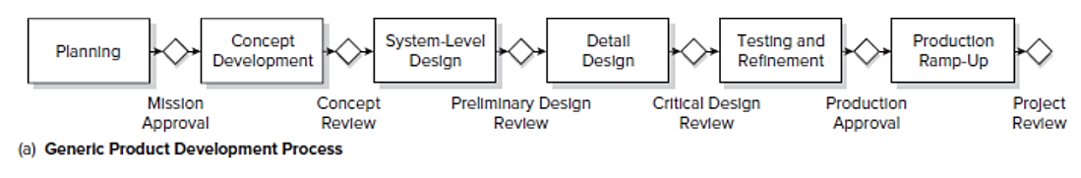

(Product Design and Development, Ulrich, Eppinger, Yang)

# Prototyping Plan

* Define Purpose: Regular Use (Used to see how it works and explain what it should do)
  + To test the feasibility of the selected concept design through analytical and physical prototypes and to understand the interaction between the user and the device for optimization of the user interface.
* Establish Level of Approximation (Most likely analytical for simulation testing purposes)
  + For the posture correcting device, we can potentially create the software side of the prototype as near to a final product as possible. However, any hardware will be look-alike models or simulated models.
  + Most of the prototyping models would be soft models for visualization purposes, but there may be a few hard models to better understand the sizing of the device to fit the components and the location and appearance of the device so that it is not too noticeable when it is worn by the patients.
* Outline Experimental Plan (Use simulations)
  + Product planning/management
  + Preliminary/concept design (online circuitry simulators, Arduino IDE)
  + Product specifications
  + Product design (Arduino schematic)
  + Component purchasing
  + Product assembly
  + Project development and presentation
  + Product testing
* Create Schedule for Testing
  + Future/After this semester: Concept testing, bug fixes/troubleshooting design, visit Cardinal Hill for in-person survey/feedback
* Other
  + During our meeting with Mr. Tohidi, we discussed possible sensors and methods of attaching the device to the patient, possibly integrating it into their clothes. He mentioned how using a softer material for the device may be beneficial, instead of using hard plastic or similar materials, and how we could make a 3D scan of the back to help with prototyping. It would be possible to 3D print the casing for the components (e.g., the circuit) and design either a small or a larger device. Students in the School of Art and Visual Studies could help provide illustrations or other forms of representation of our device and its specifications and can help with the user interface aspect of the design.

# Data Collection Plan

* Interviews
  + Main source of collecting raw data
  + Performed in-person, if allowed; otherwise, phone calls will be initiated
  + A light incentive will be offered for reimbursement of the interviewees’ time
  + Performed with physicians/healthcare team as well as the patients and/or family members of the patients
  + 10 total
* Focus groups
  + Unnecessary for our project
* Observing the product in use
  + Will be conducted in-person alongside the 10 interviews to gauge the use of the product by the patients and others (e.g., family members) and the degree to which the patients and others understand the product

**Pre-Design Interview Questions**

Physicians

1. Would you be interested in receiving live notifications regarding a patient’s posture and positioning?
   * If so, how frequently?
2. What are some ways to unobtrusively measure patient movement?
3. How would postural correction serve to benefit the post-stroke population long-term?
4. What are the complications of prolonged poor posture within the post-stroke population?
5. How can our intervention be fine-tuned to better serve the post-stroke population?
6. Would a device like this be more suitable for long-term or short-term posture correction?
7. Could this device play a role in primary stroke prevention for post-stroke patients by increasing activity?
8. Where do you feel your patient makes/made the most progress in his or her recovery? (e.g., at home, inpatient, outpatient)
9. What would be the expected duration of use for this device for your patient?
10. How often would your patient need to use this device?
11. How helpful do you think the device would be to your patient?
12. What issues do you foresee with this device with respect to the technical characteristics?

Industrial Design

1. Compared to current posture correction devices on the market, how should a post-stroke patient-centric device be designed? (Should also ask physician while providing information about Upright Go, etc.)
2. What issues do you foresee with using adhesives on skin?
3. What materials would be best to manage any heat dissipation of the circuit?

**Interview Questions**

Patients

1. Do you have postural correction issues or need to be reminded frequently to correct your posture?
2. If notified, are you physically able to correct your posture on your own?
3. Have you had any injuries or pain that could have been resolved with a safer posture?
4. Do you fear/are you nervous doing certain activities now? What are they?
5. Where do you feel you make/made the most progress in your recovery? (e.g., at home, inpatient, outpatient)
6. Would you feel comfortable wearing this device in public?
7. Would you be comfortable setting the device up yourself?
8. How often could you see yourself using the device? (e.g., every day, a few days a week, never)
9. How long would you expect to use the device in a single period? (e.g., <1 hour, 1 hour, 8 hours)
10. Has your posture hindered your ability to perform regular activities?
11. Are you aware of the complications caused by prolonged impaired posture?
12. How helpful do you think the device would be to you with respect to the complications? (Should also ask about sensation within weak side)
13. What type of feedback would you expect to be most beneficial to you? (phone notification, vibration, sound, etc.?)
14. Would you be comfortable feeling vibrations from the device?
15. Can you sense mechanical or electrical sensation on X side? (Must simplify language)
16. How important are aesthetics to you? (e.g., very important, mildly important, not important at all, no opinion on the matter)

Family Members

1. Where do you feel your family member makes/made the most progress in his or her recovery? (e.g., at home, inpatient, outpatient)
2. Do you have any reservations about your family member using a device like this?
3. How much would you be comfortable paying for a device like this?
4. Are you in a position to constantly monitor XX? If not, how would posture and fall detection help your family?
5. Would you be willing to be an emergency contact for the device?

# Task List

|  |  |
| --- | --- |
| **TASK** | **ESTIMATED DURATION (HOURS)** |
| Product Selection | 5 |
| Design Selection | 5 |
| Material Selection | 3 |
| Product Prototyping (Hardware + Software) | 8 |
| Execution Selection | 1 |
| Prototyping | 12 |
| Data Collection Method Selection + Data Collection | 6 |
| Final Product Development | 15 |
| Product Testing | 12 |

# Design Structure Matrix

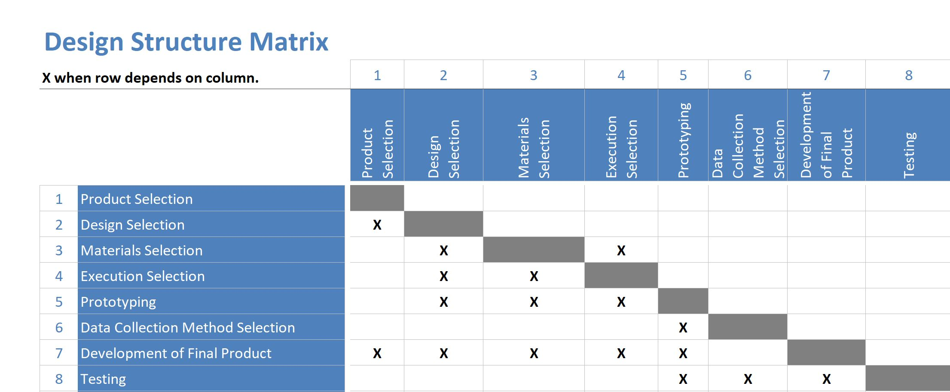

# Gantt Chart

[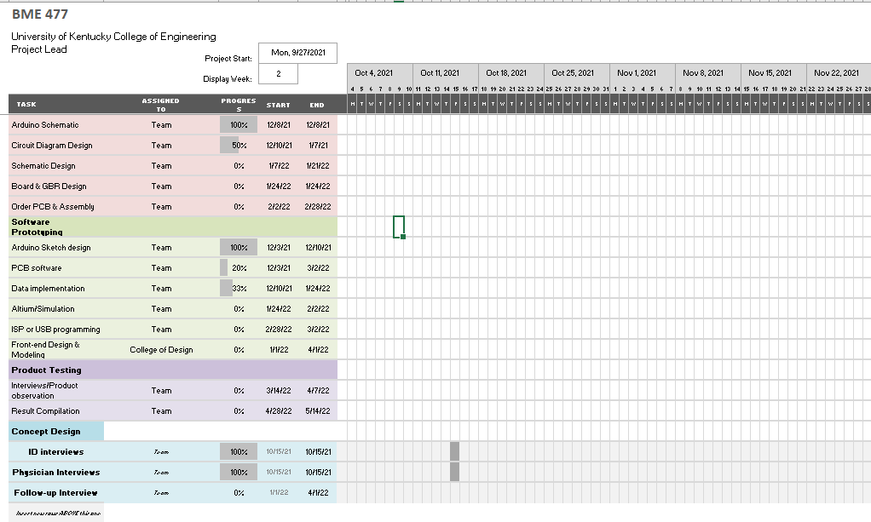](https://luky-my.sharepoint.com/:x:/g/personal/bagr247_uky_edu/EYodu6h4LwZDvXZFV6JnBPYBVh6tkhF27bSFz7Ixi3TPfQ?e=Cdzbmw)

# PERT Chart

*In days

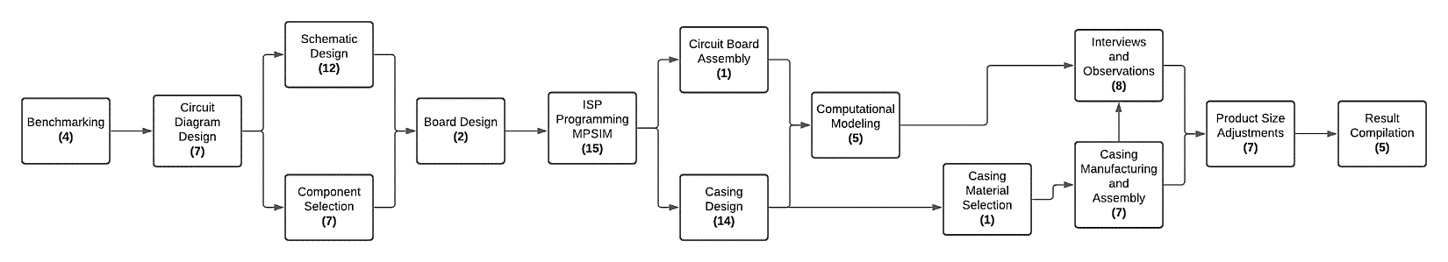

# Budget

|  |  |
| --- | --- |
| **ITEM (QUANTITY)** | **AMOUNT ($)** |
| *Product Comparison* |  |
| 1. UPRIGHT GO S (1) | 59.95 |
| 1. UPRIGHT GO 2 (1) | 79.95 |
| 1. Necklace (1) | 19.95 |
| 1. Posture Correcting Neuroband Shirt (1) | 99.95 |
| *Prototyping Materials* |  |
| 1. Arduino Nano 33 BLE with Headers (5) | 112.50 (22.50 each) |
| 1. Straps/Attachment Method | 400 |
| 1. Miscellaneous | 1000 |
| *Professional Services* | 1000 |
| *Materials for Final Product* |  |
| 1. Circuit Components |  |
| * 1. Arduino Nano 33 BLE with Headers (2) | 45 (22.50 each) |
| * 1. BLUENRG-232N | 2.75 |
| * 1. SAMD21 (microchip) | 2.25 |
| * 1. LSM6DS3TR | 2.89 |
| * 1. VBUS | 1.49 |
| * 1. Ecc608 | 0.37 |
| 1. Straps/Attachment Method | 300 |
| 1. Miscellaneous | 750 |
| *Incentives for Interviews* | 300 |
| ***Total*** | 4177.05 |

# Risk Plan

|  |  |  |  |
| --- | --- | --- | --- |
| **RISK** | **LIKELIHOOD** | **IMPACT** | **ACTIONS TO MINIMIZE RISK** |
| Financial cost exceeds budget | Medium | High | * Develop inexpensive prototypes in the beginning to ensure confidence in the final product * Keep track of expenditures throughout the design process and make budgetary adjustments for future tasks, as needed, so the budget will not be exceeded, or it will be less likely that the budget will be exceeded |
| Time needed exceeds time given | Medium | High | * Stay on top of plan established * Be proactive |
| Materials needed are unavailable | Low | Medium | * Check for materials and their availability/lead time before beginning the prototyping/development stage * Have a second-choice material in mind |

# Product Specifications

**Needs List**

*These needs were compiled by the design team.

1. Independent posture correction/improvement
2. Device keeps its charge a long time
3. Device increases awareness of the patient’s weakened side
4. Device is hypoallergenic
5. Device is easy to put on and off
6. Device is durable enough to be worn during any ADLs
7. Device provides posture/health information to those involved in treatment plan
8. Device instills confidence and improves patient’s ability to see improvement
   1. Security from falls
9. Device is affordable
10. Device is comfortable

**Metrics List with Values**

1. Feedback system (binary) | Marginal: Yes; Ideal: Yes
2. Battery life (hours) | Marginal: >8 hours; Ideal: >12 hours
3. Track changes (# times catches bad posture) | Marginal: ≥10 times/day; Ideal: All instances
4. Material – latex-free, etc. (binary) | Marginal: No latex or other materials known to lead to allergic reactions; Ideal: No latex or other materials known to lead to allergic reactions
5. A) Time to place the device on the specific location of the body (s) and time to remove the device (s) | Marginal: <1 minute; Ideal: <30 seconds

B) Location of device on the body (list) | Marginal: Upper back only; Ideal: Arm, upper chest, upper back (variable locations)

1. Materials’ strength | Marginal: <120 MPa; Ideal: <100MPa
2. Options for providing this information (list) | Marginal: In-person only; Ideal: App for computer or smartphone and in-person
3. Instill confidence/improve ability to see improvement (subjective: 1 [very good], 2 [good], 3 [neutral/no opinion], 4 [not good], 5 [not very good]) | Marginal: 3; Ideal: 1-2
4. Cost of device (U.S. dollars) | Marginal: <$75 with 25 adhesives; Ideal: <$55 with 25 adhesives
5. Comfortable (subjective)--Wong-Baker Comfort Scale | Marginal: 1-3; Ideal: 1

**Table of Needs and Metrics**

|  |  |  |  |  |
| --- | --- | --- | --- | --- |
| **NEED** | **METRIC** | **UNIT** | **MARGINAL VALUE** | **IDEAL VALUE** |
| Independent posture correction | Feedback system | Binary (Yes/No) | Yes | Yes |
| Long-lasting charge | Battery life | Hours | >8 | >12 |
| Increases awareness of patient’s weakened side | Sensitivity/Specificity of posture change | # times device catches “bad” posture | >= 10 times a day | 100% |
| Is it hypoallergenic? | Material | Binary (Yes/No) | Yes | Yes |
| Device is easy to put on and off | Time to place and remove the device | Seconds | <60 | <30 |
| Device is easy to put on and off | Location of device on body | List | Upper back only | Variable locations (e.g., arm, upper chest, upper back) |
| Is it durable? | Material strength and toughness | MPa | <120 MPa | <100 MPa |
| Provides information to healthcare provider | Options for providing information | List | In person-only | App for computer or smartphone and in-person |
| Instills confidence | Subjective rating | 1-5 rank | 3 | 1 |
| Is it affordable? | Cost of device | US dollars | <$75 | <$55 |
| Is it comfortable? | Wong-Baker Comfort scale | 1-5 rank | 1-3 | 1 |

**Needs-Metrics Matrix**

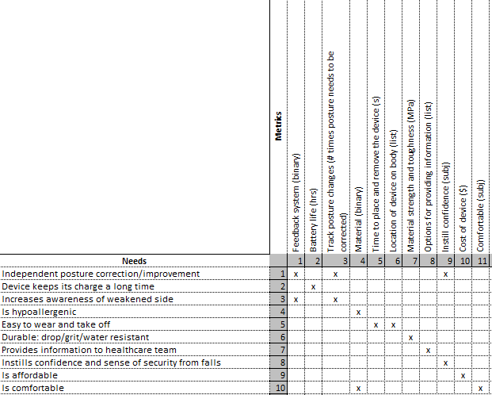

# Concept Generation

**Functional Decomposition for Posture Correcting Device**

Sub-Problems:

1. Monitoring the posture
2. Comparing posture to upright/correct posture
3. Feedback/Notification system (to patient)
4. Relaying data/information to respective entities

**Final Set of Concepts**

*The method of concept generation is provided in parentheses at the end of each concept or sub-problem.

1. Monitoring the posture (including detecting/measuring the posture and device attachment/set-up)
   1. One wearable sensor/IMU located on the back (variable vertical placement) via strap or adhesive (Literature search: Ghislieri et al. (2019))
      1. Upper back
      2. Middle of the back
      3. Lower back
   2. One wearable sensor/IMU located on the sternum (variable vertical placement) via strap or adhesive (Literature search: Nguyen et al. (2021))
   3. One wearable sensor/IMU located on wheelchair via strap or adhesive (Literature search: Ghislieri et al. (2019))
   4. One wearable sensor/IMU located on hip via strap or adhesive (Literature search: Ghislieri et al. (2019))
   5. Two wearable sensors/IMUs located on the shoulders via strap or adhesive (Literature search: Ghislieri et al. (2019))
2. Comparing posture to upright/correct posture
   1. Compare detected posture to averaged posture data from the general population (Individual)
      1. Have a standardized value for the extent of their condition to be the base point and “correct” posture
   2. Set reference at set up and compare distance of vertebra (multiple sensors, more space between sensors means leaning forward) (Individual)
   3. Have them sit/stand in as close to perfect posture as possible and set that as the reference; when it’s off, the sensation of noise or vibration will be in effect (Individual)
   4. Leaning more than X degrees (Individual)
   5. For two IMUs, they could be compared to each other to notify the subject when he/she is leaning more to one side than the other (Individual)
   6. Visual representation on phone of the posture measured by the IMU(s) that updates in real-time so the patient can see which direction he/she needs to move to improve his/her posture (Related stimuli)
   7. Orientation decomposition (Literature search: Nguyen et al. (2021))
3. Feedback/Notification system (to patient) (Individual)
   1. Electrical stimulation
   2. Mechanical feedback
   3. Auditory (directly from device)
   4. Phone alert (mobile application) auditory or visual
      1. Weekly improvement/performance reports
      2. Text alerts
      3. Emails
      4. Image/animation of postural sway
   5. Combination of any of these
4. Relaying data/information to respective entities (Individual)
   1. Permission to handle emergencies
   2. Sent on a requested basis via application/email/text, etc.
   3. Sent on a cycled basis (daily, weekly, monthly)

**Concept Classification Trees**

***Concept Classification Tree for Sub-Problem 1***

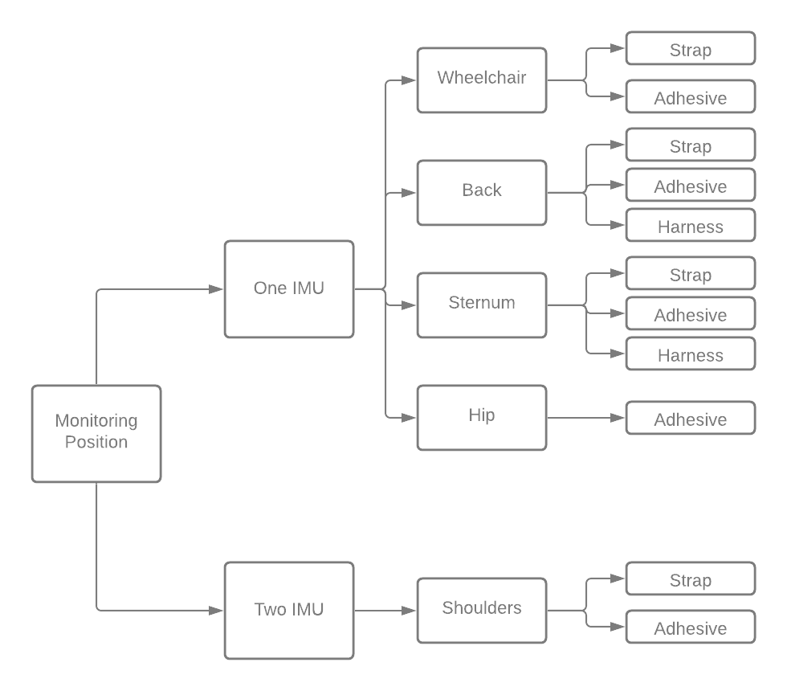

***Concept Classification Tree for Sub-Problem 2***

SP2=Comparing posture to upright/correct posture

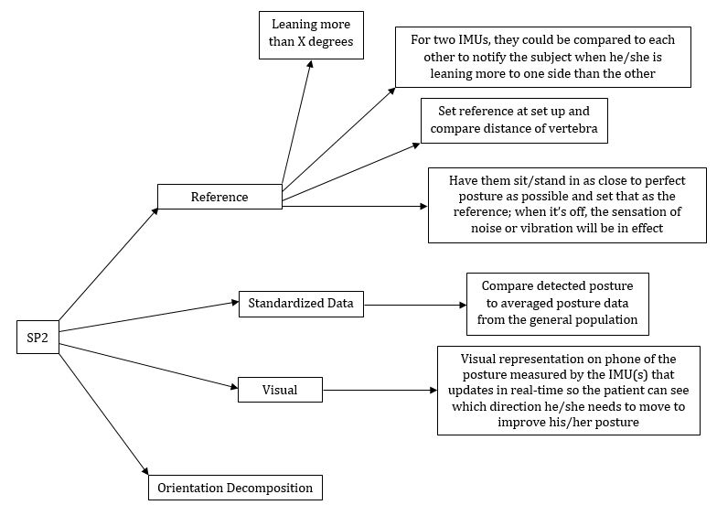

***Concept Classification Tree for Sub-Problem 3***

***Concept Classification Tree for Sub-Problem 4***

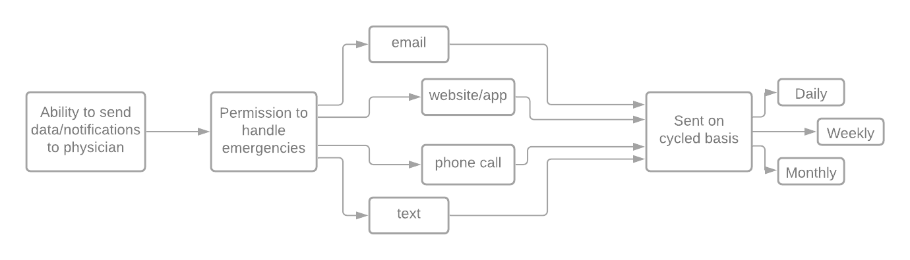

**Concept Combination Tables**

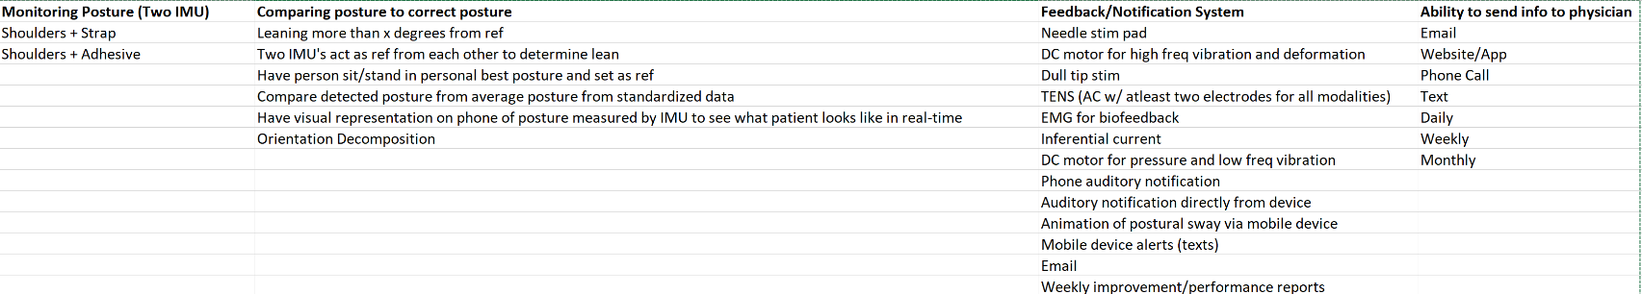

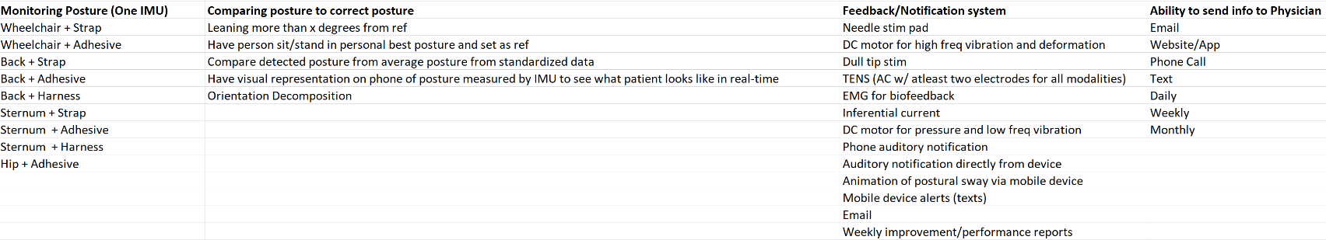

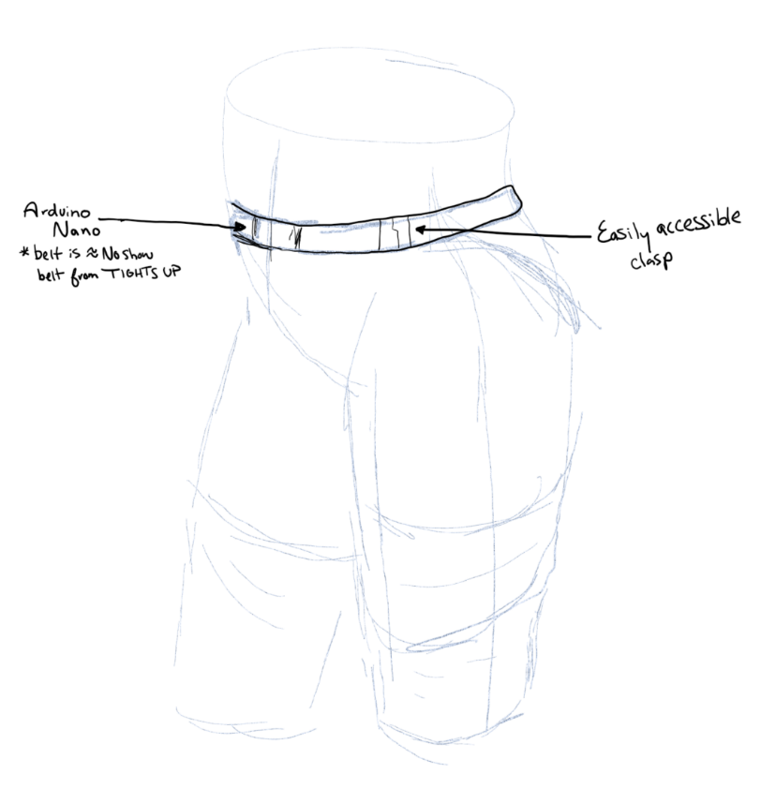**Concept Combination Sketches and Descriptions**

***Concept Combination 1***

IMU device is held at waist with belt that is invisible under clothes (primarily measures body sway). It uses a public dataset to create a threshold to detect a fall and incorrect posture.

***Concept Combination 2***

Device consisting of two IMU’s measuring at upper back and around L5 vertebra worn via harness. The device would measure body sway and spine rotation and provide an animated visual representation to the user from an app.

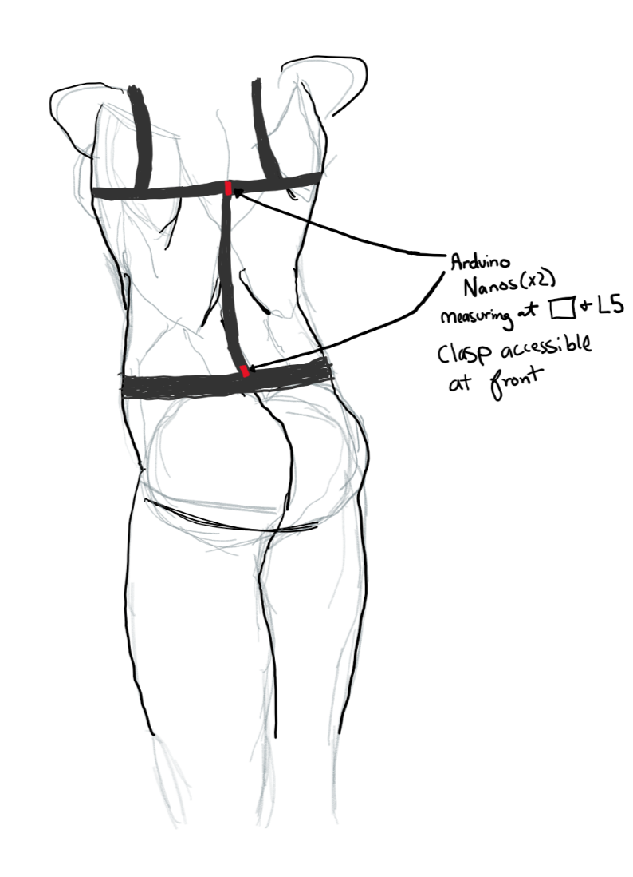

***Concept Combination 3***

A single IMU attached via adhesive to the sternum. This device would measure the trunk’s inclination angle and compare it to a public dataset. A deviation from a threshold would trigger a phone alert.

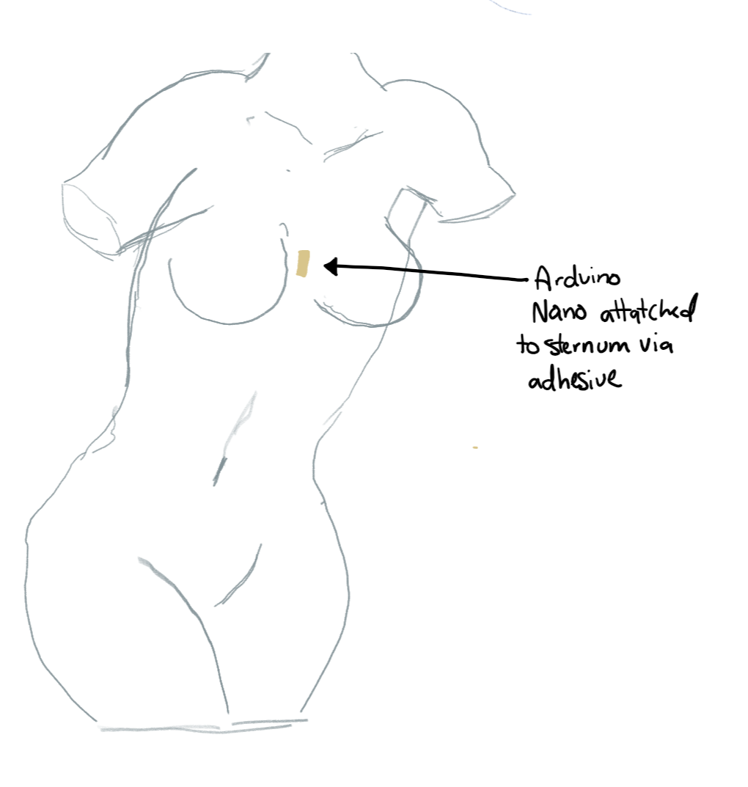

***Concept Combination 4***

Two IMUs will be attached via a strap below the shoulders and under clothes (~1-2 in. below the armpits to avoid, or at least minimize, discomfort), with the Velcro of the strap being secured in the front of the person to allow for easier placement. One of the IMUs will serve as the reference sensor to which the second IMU will be compared to determine if the person is leaning. For the baseline, or proper, posture, the two IMUs are aligned (within ~±5°), and a deviation from this baseline in which the second IMU is higher or lower than the reference IMU will indicate leaning. The person using these IMUs will receive a mobile device (text) alert from the interfaced app as the feedback/notification system to inform him or her of their improper posture, and the physician or other person of contact will also receive a text alert with similar information.

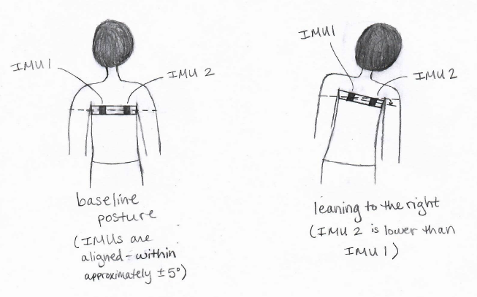

***Concept Combination 5***

One IMU will be attached via a strap to the lower back (at ~L3 or L4 and under clothes), and a reference posture will be established in which the person is standing or sitting vertically (or almost vertically). When the person leans in a sagittal manner (in either direction) from the reference posture by a certain amount (X°, which may be standard for all users or specific to each user), the app interfaced with the device will send a mobile device (text) alert to the person to notify him or her of his or her improper posture. The physician or other person of contact will receive a phone call from the app when any leaning occurs.

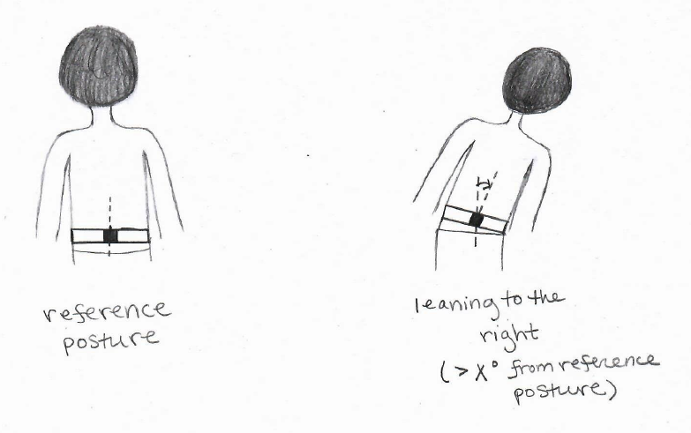

***Concept Combination 6***

One IMU will be attached via an adhesive to the lower back (at ~L3 or L4 and under clothes). The reference posture will be based on the person’s best posture when sitting or standing, and the person will receive auditory notifications directly from the device whenever deviations in the personal best posture are detected. The interfaced app will send an email alert to the physician or other person of contact whenever these deviations occur.

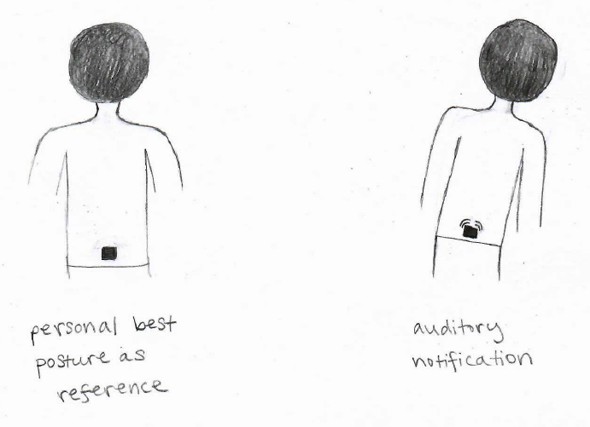

***Concept Combination 7***

Two IMU attached to Hip via a strap. Measures via reference to one IMU. Notification with vibration or mechanical stim. Conveys data to physicians through text on a routine manner.

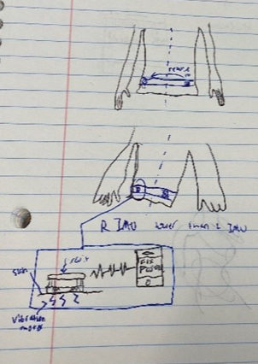

***Concept Combination 8***

One IMU placed on the upper back via hypoallergenic adhesive. Measures through leaning more than x degrees. Attached through adhesive, uses electrical stimulation (low frequency vibration). Relays data through mobile application available to the user, and anyone the user gives permission to.

***Concept Combination 9***

One IMU will be attached to the sternum via a harness. The device will measure postural sway by detecting a lean more than X degrees from a reference point set at calibration. The device will notify the user through audio with a delay set by the user. A summary of information will be sent weekly to physicians or on an emergency basis.

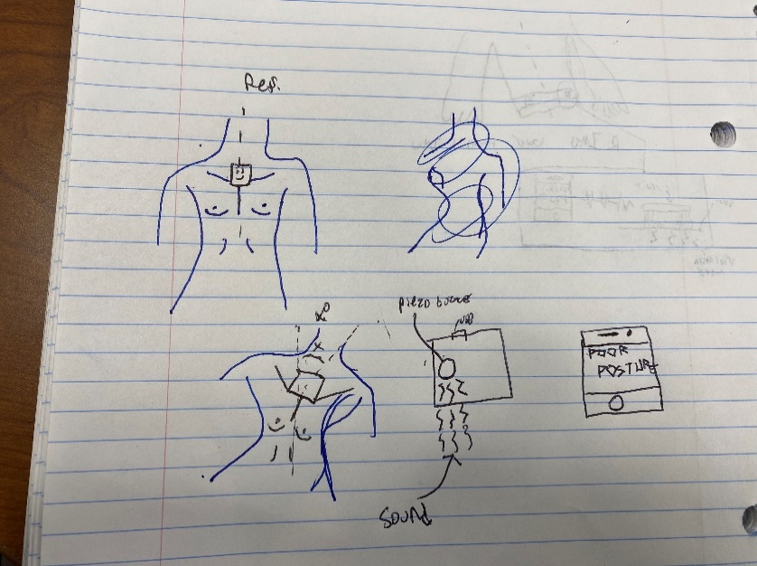

***Concept Combination 10***

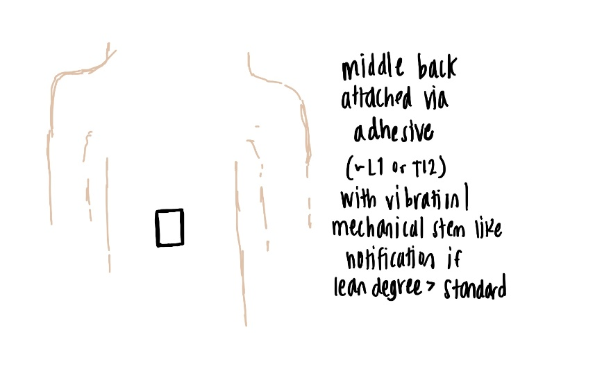

***Concept Combination 11***

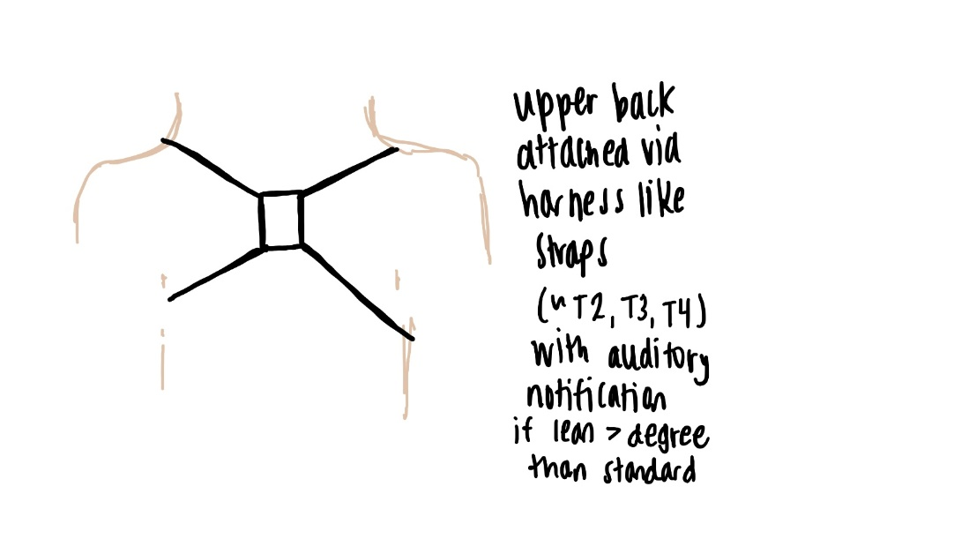

***Concept Combination 12***

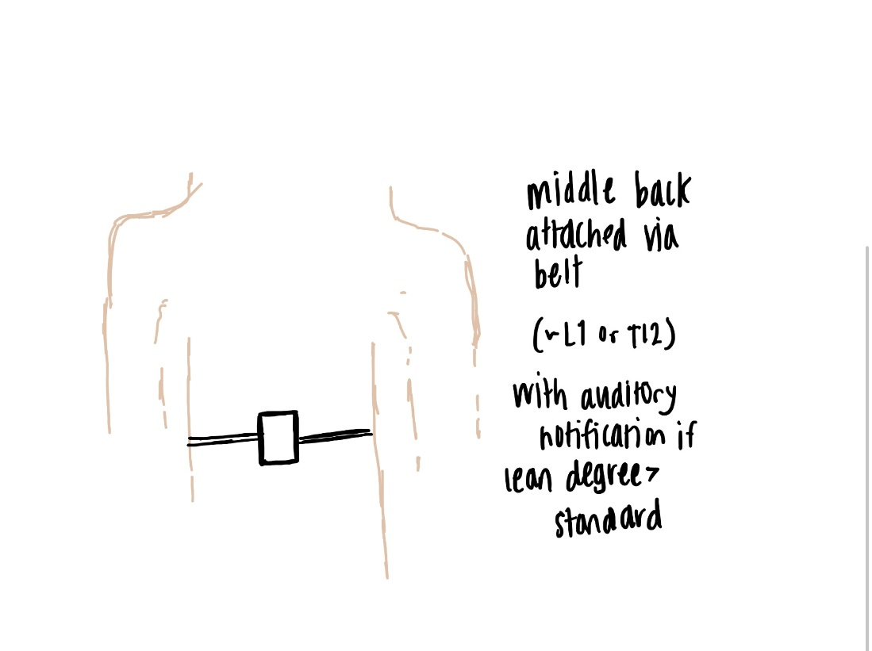

# Concept Selection

**Criteria List**

*These criteria were based on the needs listed previously and were compiled by the design team.

1. Supervision
2. Feedback system
3. Battery life
4. Track changes
5. Material comfort
6. Time to place/remove device
7. Materials’ strength
8. Options for providing information
9. Instills confidence
10. Cost
11. Location of device on body

**Concept Screening**

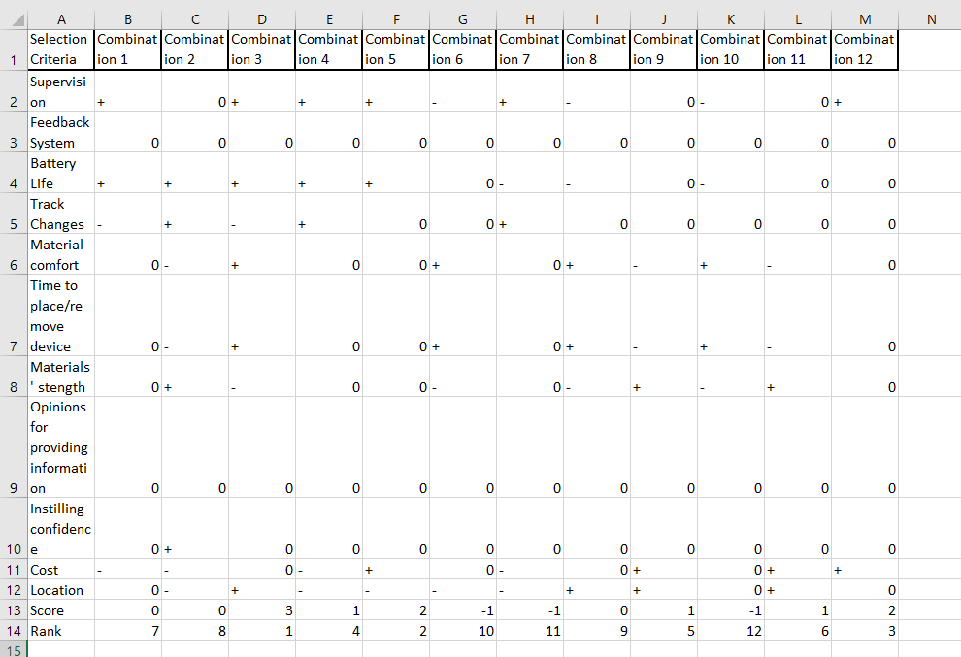

The concept combination with the best rank is Combination 3, which involves a single IMU attached via adhesive to the sternum. This device would measure the trunk’s inclination angle and compare it to a public dataset. A deviation from a threshold would trigger a phone alert.

Since only one concept combination had the best rank after performing concept screening, we did not perform concept scoring.

# References

<https://www.cdc.gov/stroke/index.htm>

Ghislieri, M., Gastaldi, L., Pastorelli, S., Tadano, S., & Agostini, V. (2019). Wearable Inertial Sensors to Assess Standing Balance: A Systematic Review. *Sensors (Basel, Switzerland)*, *19*(19), 4075. https://doi.org/10.3390/s19194075

Ghorbanpour, Z., Taghizadeh, G., Hosseini, S. A., Pishyareh, E., Ghomsheh, F. T., Bakhshi, E., & Mehdizadeh, H. (n.d.).  Overload of anxiety on postural control impairments in chronic stroke survivors: The role of external focus and cognitive task on the automaticity of postural control. PLOS ONE. Retrieved December 10, 2021, from https://journals.plos.org/plosone/article?id=10.1371%2Fjournal.pone.0252131.

Hugues, A., Di Marco, J., Janiaud, P., Xue, Y., Pires, J., Khademi, H., Cucherat, M., Bonan, I., Gueyffier, F., & Rode, G. (2017). Efficiency of physical therapy on postural imbalance after stroke: study protocol for a systematic review and meta-analysis. *BMJ open*, *7*(1), e013348. <https://doi.org/10.1136/bmjopen-2016-013348>

Nguyen, G., Maclean, J., Stirling, L., 2021. Quantification of Compensatory Torso Motion in Post-Stroke Patients Using Wearable Inertial Measurement Units. IEEE SENSORS JOURNAL 21, 15349-15360.